CS 255 System Design Document

David Silva
Southern New Hampshire University
CS-255: System Analysis and Design
Instructor: Aline Yurik
December 9, 2025

UML Diagrams

UML Use Case Diagram
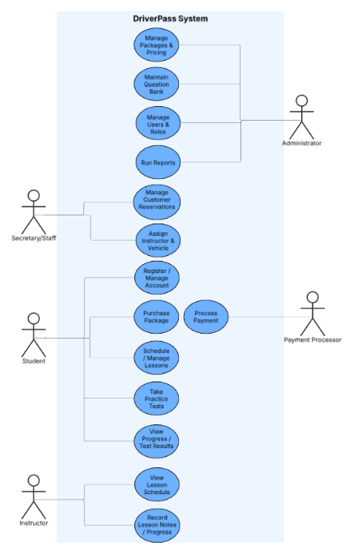

UML Activity Diagrams
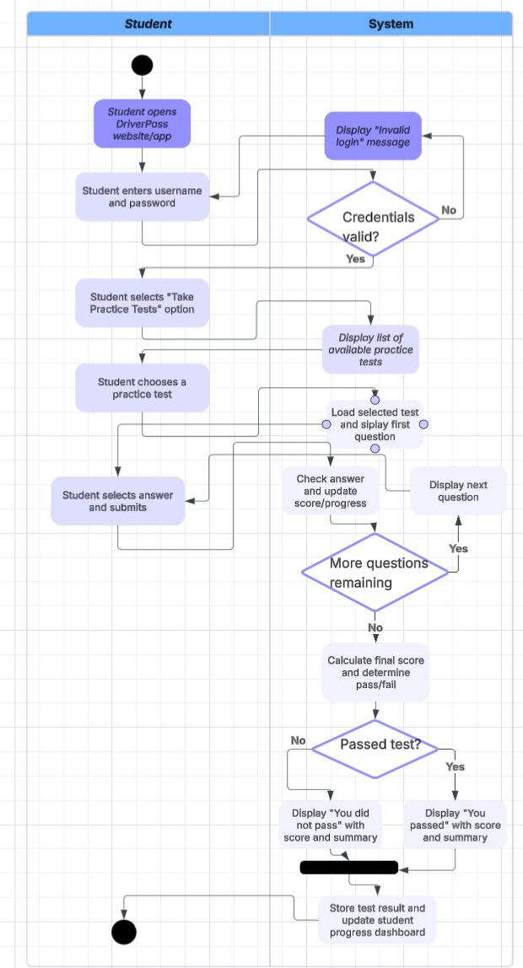
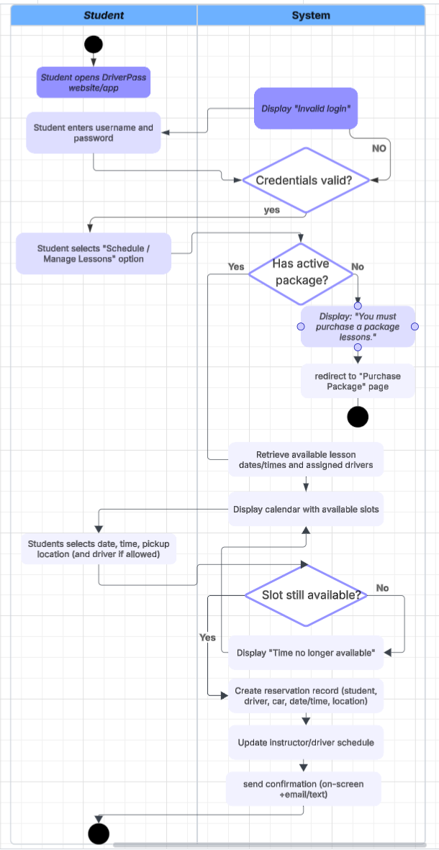

UML Sequence Diagram
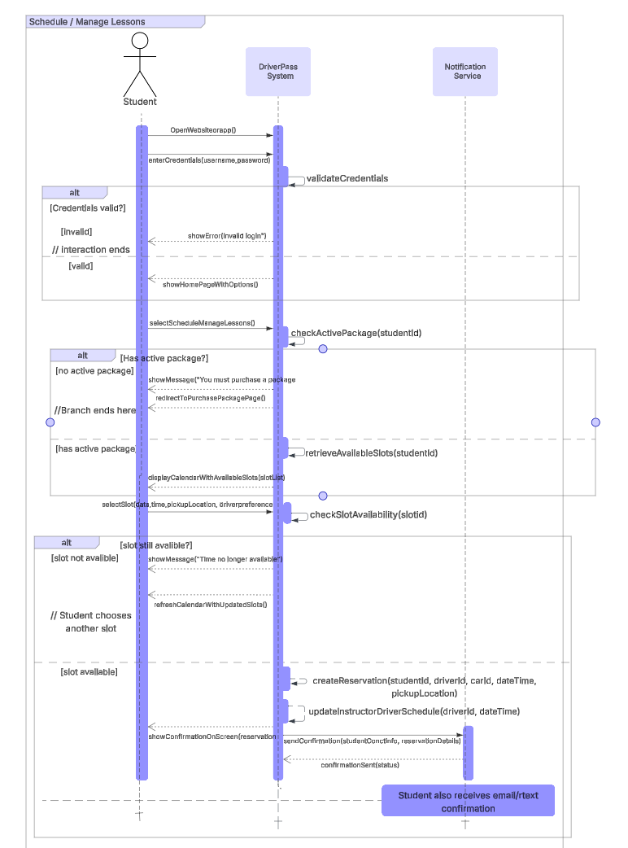

UML Class Diagram

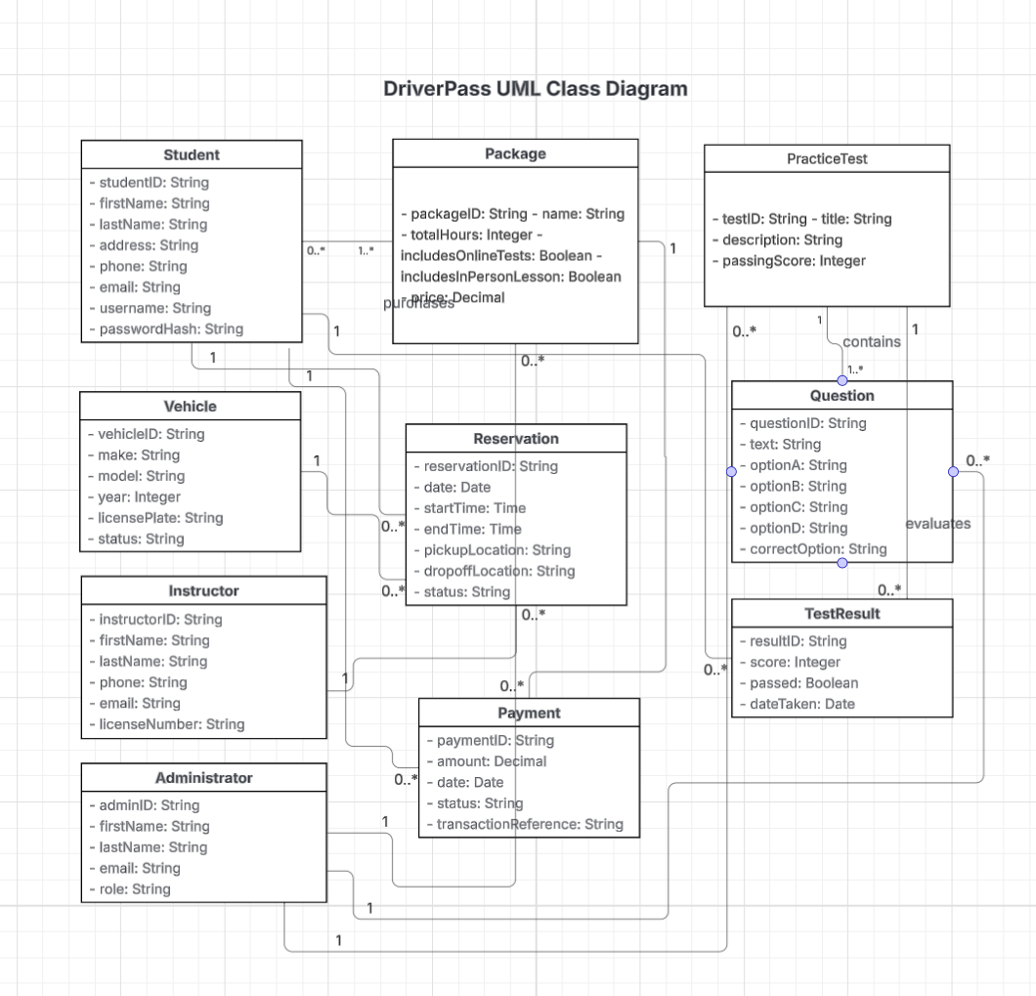

Technical Requirements
The technical requirements for the DriverPass system are based on the features shown in the UML diagrams, including user login, lesson scheduling, practice testing, payments, and instructor management. To support all these functions, the system needs a combination of reliable hardware, appropriate software tools, and strong security measures. The requirements below describe what is necessary for the system to operate smoothly and meet the client’s needs.

Hardware Requirements
- A cloud-based server environment (such as AWS, Azure, or Google Cloud) to host the website, database, and any background services.
- Enough server storage to hold user accounts, reservation history, test data, lesson information, and administrative records.
- Adequate processing power and memory so the system can support multiple users at the same time without performance issues.
- Backup and recovery storage to protect the system in case something fails or data is lost.
Software Requirements
- A server-side web framework (for example, Java Spring Boot, .NET Core, or Node.js) to handle the main logic of the system, including login, scheduling, and data processing.
- A relational database system (such as MySQL, PostgreSQL, or SQL Server) for storing structured data like students, instructors, lessons, packages, payments, and test questions.
- A modern front-end interface built with HTML, CSS, JavaScript, and possibly a framework like React or Angular to make the system easy to use.
- Integration with a secure third-party payment service to handle credit card transactions.
- An email or SMS notification service (for example, SendGrid, Twilio, or AWS SNS) to send confirmations and updates to users.
- Secure handling of passwords and user data, including encryption and the use of HTTPS.
Tools and Development Requirements
- A version control system such as GitHub or GitLab to track code changes and support team collaboration.
- CI/CD tools to help automate testing, deployment, and updates.
- UML diagramming tools (Lucidchart, Visual Paradigm, or draw.io) for maintaining system models.
- Monitoring and logging tools to track errors, performance, and system activity.
Network and Security Requirements
- HTTPS encryption to protect sensitive information, especially during login and payment.
- Role-based access control so each type of user (student, instructor, staff, administrator) only sees the features meant for them.
- Input validation and server-side security measures to protect against threats like SQL injection or unauthorized access.
- Regular database backups and a disaster recovery plan.
- Proper session management to prevent users from accessing the system without authorization.

